Instructions for first-time login to WeBWorK

First go to my WeBWorK page: http://euler.vaniercollege.qc.ca/webwork2/seely  http://euler.vaniercollege.qc.ca/webwork2/rags  (as appropriate for your class)  Log in with your student number as username and as password. (You will – you must! – change your password next!) | 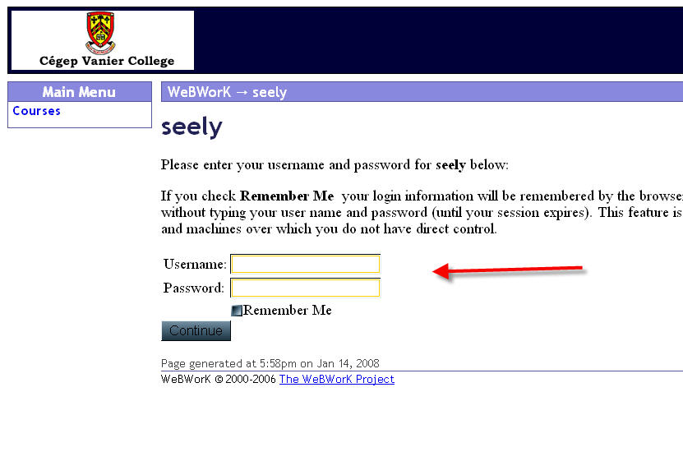
When you log in you will see a screen with the homework assignments listed. (Usually you will click on the one you want to do.)  But first: change your password and enter your email address. To do this, first click “Password/Email”, as indicated in the picture. | 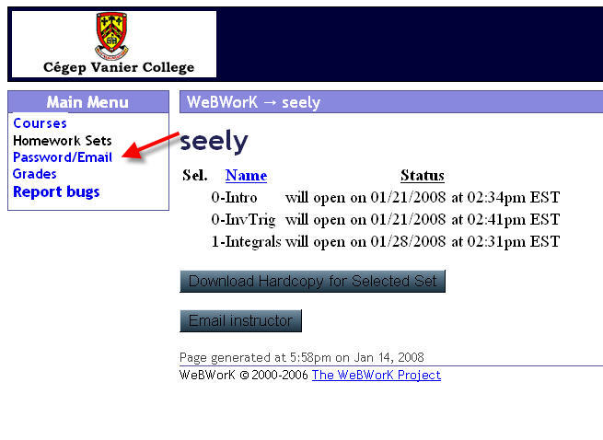
You will get the usual sort of dialogue box: just enter your current password (initially your student id), and then your new one (and confirm it). Next enter your email address (there will not be a current one the first time you do this, but if you need to alter your email address, the former one would be displayed, as you see in the picture).  YOU MUST ENTER A VALID EMAIL ADDRESS!! (Speak to me if that’s not possible for some reason, please.) | 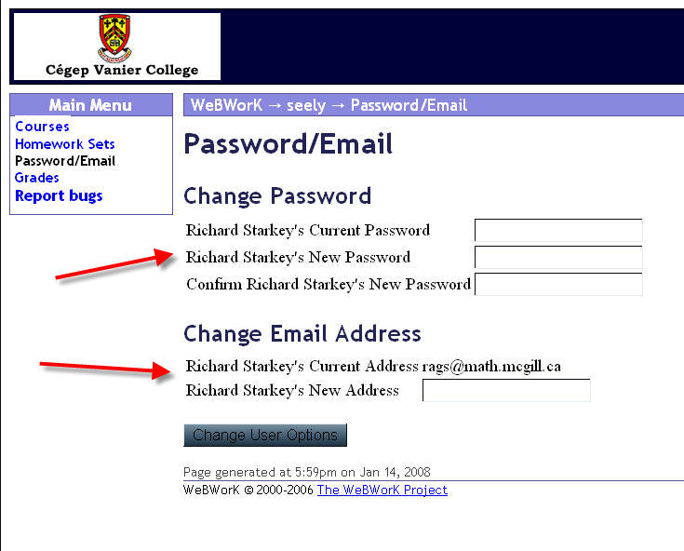
Then go back to Homework Sets (click on that phrase), and do the first undone assignment.  Let me know if you have problems. Since you’ve entered your email address, whenever you click “email instructor”, not only will I get your message, but I’ll also know who it came from and be able to reply. (If you don’t enter your email address, I won’t know either, and you might as well not email your question, as you won’t be able to get your answer!) | 